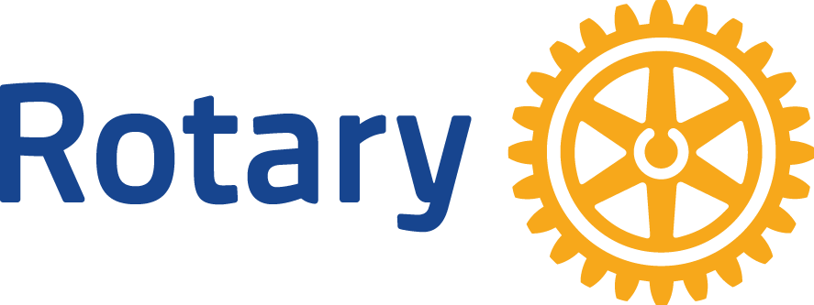

Date: No. 1 Welcome to Rotary

Dear (First name):

On behalf of all of our club members, welcome to the Rotary Club of .

This is the first in a series of letters to help you understand more about Rotary and to assist you in engaging in the activities of our club.
Your sponsor _________________ has recognized you as a person of good character and reputation and as a leader in our community. Our members are delighted that you joined the club and are looking forward to getting to know you.
We meet weekly to learn more about our local and global communities. Top notch speakers and discussions allow us to get to know each other and to frame future activities for club members. Make an effort to sit with different people each week in order to get to know more members and allow more members to know you. We refer to each other using first names because we are all equals in Rotary.
Friendship and fellowship are the cornerstones of Rotary. Through these relationships and the exchange of ideas, we get to know each other and take actions to improve our community. It is difficult to build these relationships without interaction, one of the reasons we meet weekly. We develop better plans if they are informed by diverse views and experiences. The absence of any member deprives us of his or her experience.
Contributions of all members make for a stronger club and a better community. You will find that you miss a lot if you miss one of our meetings or social events!
To introduce you to our large and extended organization I will send you one letter a week. The letters will describe Rotary, our purpose and mission. I hope they help you decide what part you wish to play in this club. It will be through your actions that you become a Rotarian—a term that means much so much more than just being a member of a club.
For more updates and information visit our website __________________ and Facebook page _______________
I am looking forward to seeing you again at our next meeting. Yours in Rotary Service,

Rev 2018

