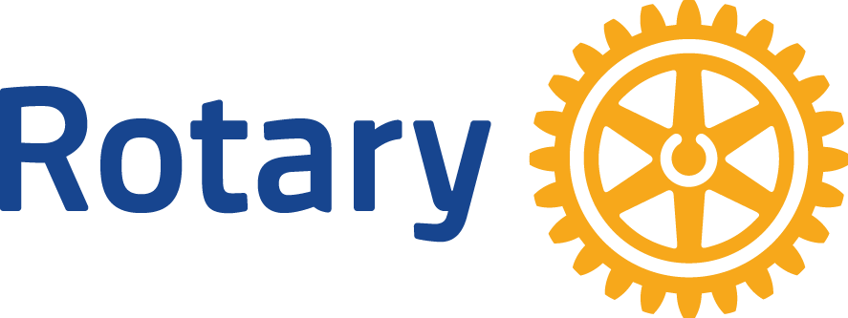
Date: No. 4 Basics of Rotary

Dear (First Name):

Did you know that in 1905 a young lawyer - Paul Harris - founded the first Rotary club in Chicago? He invited a few business and professional men together so that they might recapture the friendliness and camaraderie of the small town life many of them had enjoyed.

The club was called “The Rotary Club” because members met in rotation at their various places of work. Membership grew rapidly, and the second Rotary club was created in San Francisco in 1908. The first international Rotary club was organized in Winnipeg, Manitoba, Canada, in 1910. Rotary clubs now exist in over 200 countries and geographic areas. Although each club is unique in its culture, language, customs and traditions, all 35,000 clubs operate in similar manner. Each of us is welcome to visit any and all of them!

You and I are members of this Rotary club, the Rotary Club of _________________. Our Rotary club is a member of Rotary International (RI). The Standard Rotary Club Constitution spells out the basic requirements for membership, attendance, meetings, policies and procedures. When a club is admitted to membership in Rotary International, it is required to adopt the Standard Rotary Club Constitution. This Constitution ensures consistency for all Rotary clubs.

Rotary International World Headquarters is located in Evanston, Illinois. If you hear the term “The Secretariat,” it refers to the operations of the General Secretary and the more than 700 member staff. The Secretariat also includes seven Rotary International offices around the world. The Secretariat’s purpose is to serve clubs, districts and the administrative officers of Rotary International.

For administrative purposes, Rotary clubs are organized into districts made up of 50 to 75 clubs. Our club is part of District 5150 (Marin, San Francisco, and San Mateo counties) with a total of 43 clubs and over 1,800 Rotarians. Worldwide, our over 530 districts are grouped into 34 zones, with one Rotarian selected to represent two adjacent zones every two years. These 17 “Directors” Rotarians serve on the Board of Rotary International.

Yes, we are big and complex. But we are also a bottoms-up organization. When you shake the hand of one Rotarian you are shaking the hands of more than1.2 million other Rotarians, all working to join leaders, exchange ideas, and take action to enrich youth, ensure health, build communities, and promote peace and world understanding.

Yours in Rotary Service,

