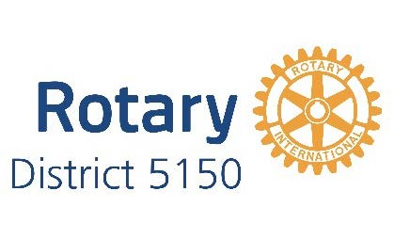
ROSE STONE FOUNDATION MATCHING FUNDS
FOR ROTARY CLUB INTERNATIONAL PROJECTS

The Rose Stone Foundation would like to support District 5150 Rotary Clubs conducting international service projects in countries that have experienced violence, and past or present conflict from wars or internal disorders. The Foundation will provide up to $50,000 in matching funds, through the District 5150 Grants Committee, for projects in such areas that will assist women and children. The primary project sponsor and Club carrying out the project must be a District 5150 Rotary Club.

These matching funds are available for Global Grant projects, District Grant projects, and Club funds only projects that will be assisting women and children in qualifying countries. Funding will be provided as follows:

Global Grants- 100% of cash contributions raised for the project
50% of DDF committed to the project by District 5150 Rotary Clubs

District Grants- 100% of the total amount of DDF to be requested in the District Grant application from
Rotary Clubs in District 5150. Note that these funds are only available to Rotary Clubs
with their own club foundations, or access to a foundation that is willing to receive and
transfer the Rose Stone funding to the project club.
Club Projects without Grant Funds- 100% of the total amount of cash that the Clubs in District 5150 contribute to the project. This funding is not available for contributions by a Rotary club to organizations outside of Rotary. Note that these funds are only available to Rotary Clubs with their own club foundations, or access to a foundation that is willing to receive and transfer the Rose Stone funding to the project club.
Rose Stone Foundation funding is limited to $50,000 per project. Funding will be in $50 increments.

Some examples of projects that would qualify for this funding are: women and children’s health projects, education and literacy projects, water and sanitation projects, and microcredit projects.

Some countries that qualify for Rose Stone Foundation funding include: All of Sub-Sahara Africa, Southeast Asia, Egypt, Lebanon, Afghanistan, Bangladesh, Colombia, Venezuela, Guatemala, Nicaragua, El Salvador, and Honduras. Other countries may qualify if information is provided that they are former conflict areas.

There are separate Application forms for each of the three types of Rose Stone Foundation contributions. Applications for Rose Stone Matching Funds are available from and should be returned to the Rose Stone Fund Coordinators for the Grants Committee, Bruce Huff and Max Huff of the RC of Sausalito. The District 5150 Grants Committee will provide oversight for clubs receiving Rose Stone Foundation funding. PDG Brian McLeran and/ or Emily McLeran Perez will provide final review and approval for all matching funds made through the Rose C. Stone Donor Advised Fund.

(Revised 1/6/2020)

